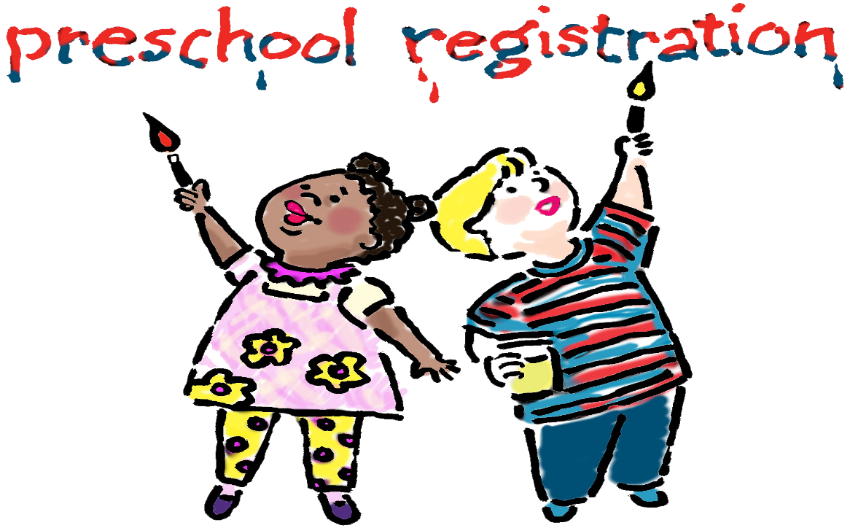
Registration for Fall 2019
- Current Fellowship Friends Preschool Families may turn in registration packets:
Now - February 21st

- Current Fellowship UMC members and families of former students may register:
9:00 am, Monday, February 25th

- Open Community Registration:
9:00 am, Tuesday, February 26th

